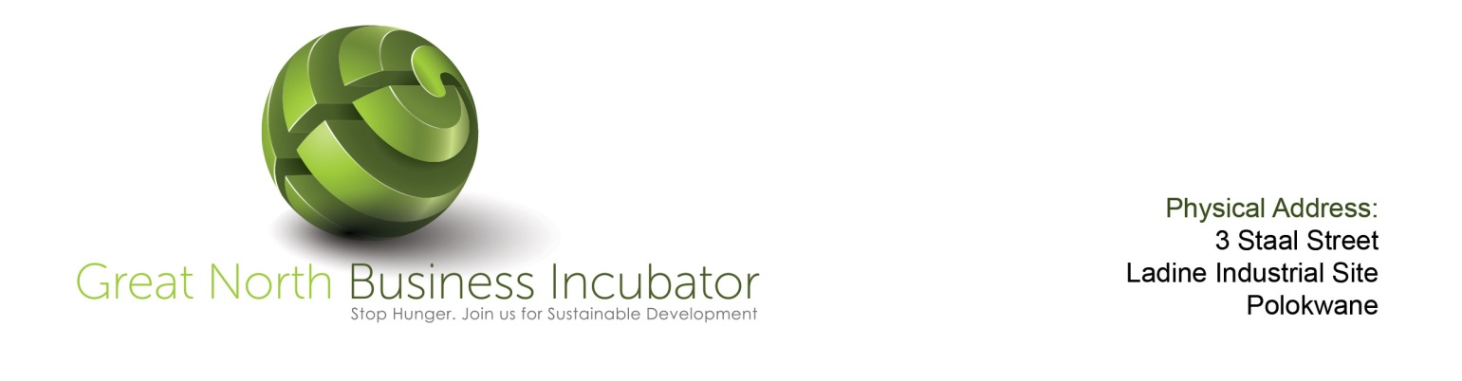
 | The following questions are designed to get your thinking about the incubator's strengths and weaknesses
 | 0=None 2=Poor 3=Fair 4=Good 5=Excellent
 | Evaluate Services Provided by Great North Business Incubator to its customers
 | Facilities: | Score
1 | Offices
2 | Office equipment
3 | Telecommunications
4 | Laboratory / prototyping / testing equipment
5 | Meeting rooms
 | Sub-total (max=25)
 | Business Development services:
1 | Provides coaching / e-coaching / on business skills and business model development
2 | Provides business extension services (accounting, legal, secretarial support, etc.)
3 | Provides assistance in preparation of business plans
4 | Provides assistance in building the business management team
5 | Organise business development training programs
6 | Provides milestone-based operational guidance and technical assistance
7 | Provide market research and product marketing assistance
 | Sub-total (max=35)
 | Assistance in Fund Raising
1 | Has its own seed investment fund
2 | Facilitates access to public business development funds
3 | Establish a network of private investors (business angels, venture capitals)
4 | Helps tenants prepare their projects to start-up venture financing
5 | Organise presentations of tenants’ projects to prospective investors
 | Sub-total (max=25)
 | Networking & Building Partnerships:
1 | Establish a network of critical business service providers & negotiated special arrangements with them
2 | Provides training and advisory services on building strategic business partnerships
3 | Organizes regular (e.g. weekly / bi-weekly) networking meeting for tenants / investors / partners
 | Sub-total (max=15)
 | Total (max=100)
 | Evaluate Your Incubator Management Practices
 | Mission & Operations: | Score
1 | Has a clearly identified mission and program goals
2 | Has developed strategic plan containing quantifiable objectives to achieve the program mission
3 | Has developed a business plan and monitor continuously its implementation
4 | Maintains a management information system and evaluates regularly program activities
5 | Incorporates program changes as the result of regular thorough and systematic evaluation
6 | Maintains effective strategic alliances and collaborations with potential partners in all its services areas
7 | Subject its finance to an annual outside audit
 | Sub-total (max=35)
 | Governance & Finances:
1 | Has sponsors and supporters capable of ensuring its continued operation and effectiveness
2 | Has a board, sponsoring agency and investors supporting the mission statement of the incubator
3 | Has a governance structure that contributes to effective program operations and tenant services
 | Sub-total (max=15)
 | The Team:
1 | Has management that keeps abreast of incubator industry best practices
2 | Sets the staff salaries at high level to attract and retain people capable of running efficiently the incubator programs
3 | Is adequately staffed to meet the key needs of and provide efficient services to its clients
4 | Has a written job description for staff and evaluates staff annually through formal reviews
5 | Strongly supports staff professional development
 | Sub-total (max=25)
 | Tenant selection, monitoring & graduation procedures:
1 | Has well defined tenant selection criteria and selects only applicants that meets these criteria
2 | Regular collects information on client performance results
3 | Reviews client financial statements on a quarterly basis at minimum
4 | Effectively utilizes new technology & business management software tools in its operations
5 | Has a formal benchmark-based graduation policy
 | Sub-total (max=25)
 | Total (max=100)

